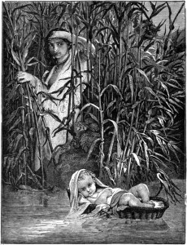
Thinking Question:

Moses’ mother had an issue of conscience. Either she obeyed Pharaoh resulting in the death of her son or she took matters into her own hands to save her son. In the Catechism of the Catholic Church, it states, ”Man has the right to act in conscience and in freedom so as personally to make moral decisions. ‘He must not be forced to act contrary to his conscience. Nor must he be prevented from acting according to his conscience, especially in religious matters.’” (1782).
Explain why Moses’ mother could reject the authority of Pharaoh in her decision based on the Catholic understanding of conscience:
Moral conscience,⁴⁸ present at the heart of the person, enjoins him at the appropriate moment to do good and to avoid evil. It also judges particular choices, approving those that are good and denouncing those that are evil.⁴⁹ It bears witness to the authority of truth in reference to the supreme Good to which the human person is drawn, and it welcomes the commandments. When he listens to his conscience, the prudent man can hear God speaking. (CCC 1777)

________________________________________________________________________________________________________________________________________________________________________________________________________________________________________________________________________________________________________________________________________________________________________________________________________________________________________________________________________________________________________________________________________________________________________________________
______________________________________________________________________________________________________________________________________________

______________________________________________________________________

______________________________________________________________________

